**Customer Journey Map**

Introduction 2

Customer Journey Map 2

The Banner 2

Our Services and Projects Sections 3

Contact Us and Footer Sections 4

Digital Tool and Techniques 5

a. Facebook Ads for digital marketing 5

i. Improving our business page. 5

ii. Facebook Ads 6

b. Google Ads for Digital Marketing 6

Digital Metrics 6

a. Facebook Insights 7

b. Google Analytics 7

Conclusion 7

References 8

# Introduction

Customer journey maps have been well known and understood to promote effectiveness for an application in terms of making it easy an efficient for a client to identify what he needs from the application in a few steps within navigating on the application (Martinez, 2018). It identifies all the key points that a customer is likely to visit in an application.

We analyze the customer journey map of a Software Company. ELS software solutions and the various technological tools to promote the company’s website in social media platforms such as Facebook and Twitter. In this report we take a look at whether the company has effectively employed the various techniques to convince a client to stay on the website and whether it has performed the necessary social outreach.

# Customer Journey Map

To effectively analyze the journey map of our website application, we need to first create a persona *client who* will be looking for a software development company to develop a website application (Alvarez et al., 2020). The customer journey map will allow the client to have a smooth user experience in identifying whether our company will be an effective option for developing an application for his agency.

To create better user, experience and improve effectiveness of a website application. A customer journey map allows for identifying key points that customers will interact with in a website. And displays all the path that a customer uses to navigate in a website before finding what he/she is looking for.

## The Banner

The first component of the website application that a client sees. It profoundly creates awareness to the user. This is more than likely to create a keen interest on what the company is about. The figure below shows an image that has a banner that is used to create awareness to the user.



*Figure 1: Banner layout*

The image has a navigation bar and a navigation bar that boldly announces the company name and what the company is all about. This is followed by a minimal text at the bottom saying ‘Developing amazing Software Solution’. The navigation bar has quite different sections to the rest of the application such as the Homepage, the *Contact Us* page and the *About Us* page.

This section part of the app has immense profoundness that might delight the customer and immediately announces if what he is seeing is actually what he is looking for.

## Our Services and Projects Sections

The next part of the application is the *Our Services* section. This outlines the various services that the company provides such as mobile application development, website application development and desktop application development.

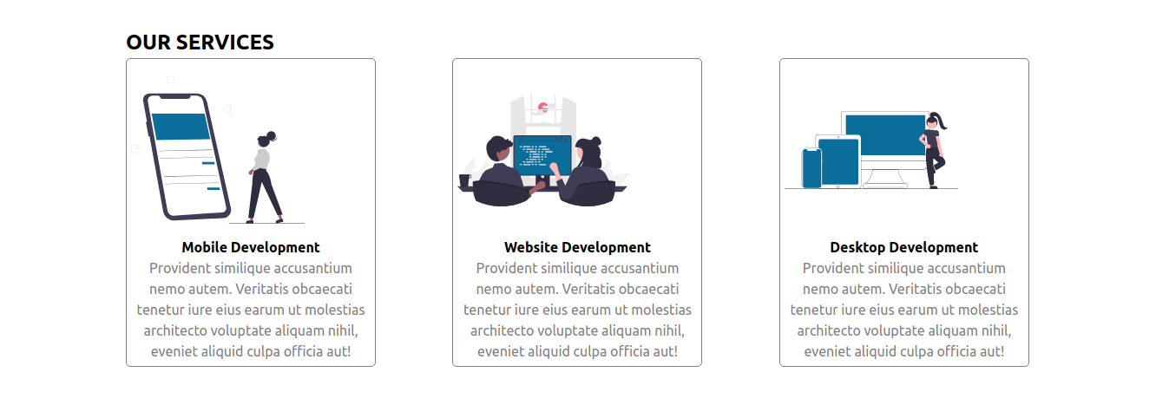*Figure 2: Our Services Section*

Our projects sections can also be included at this section of the journey map. This section on the website application will provocatively display all the projects that we have done. This part aims at establishing client confidence and build a solid trust that the company will be able to achieve whatever is needs are.

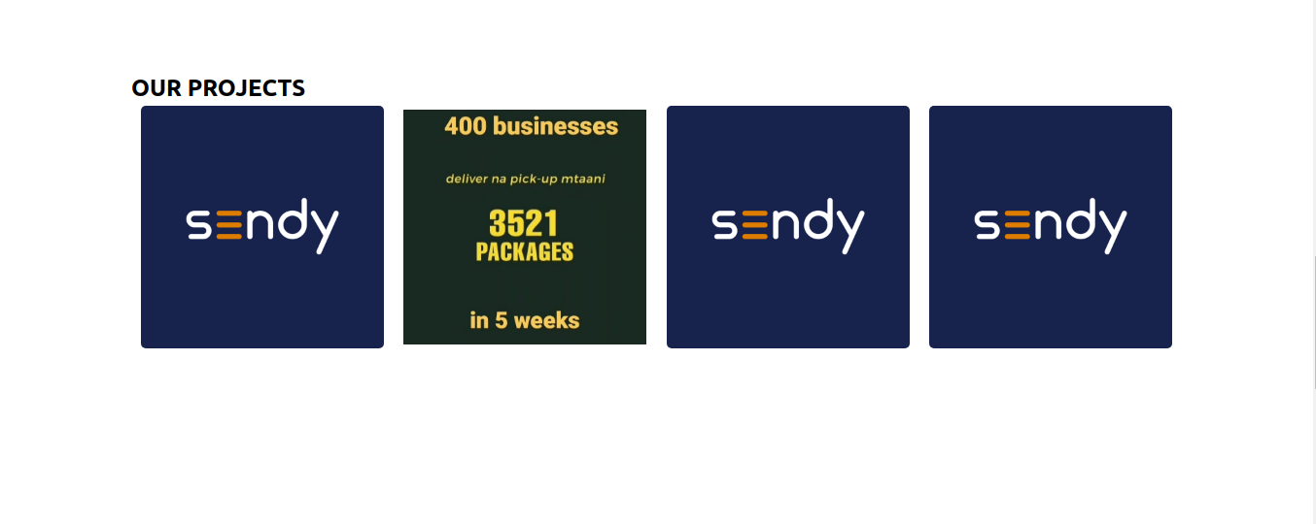

*Figure 3: Our Projects Section*

## Contact Us and Footer Sections

The contact us page is a simple layout that will enable the client to stay in touch with the company. When the customer has found whatever, he is looking for, he will simply contact the company through the C*ontact us* page. This is achieved on a series of simple steps such as entering the email address and the message that the client wants to address to the company and hitting the submit button.

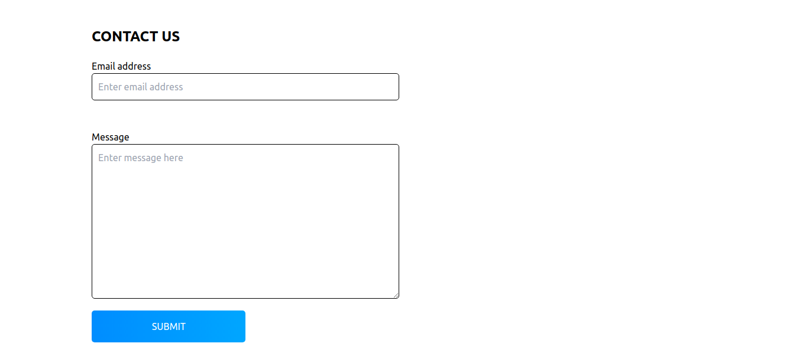

*Figure 4: Our Contact Section*

This section of the customer journey map also includes footer. This is where all the social media links, location and summary of all the important parts of the copany website are.

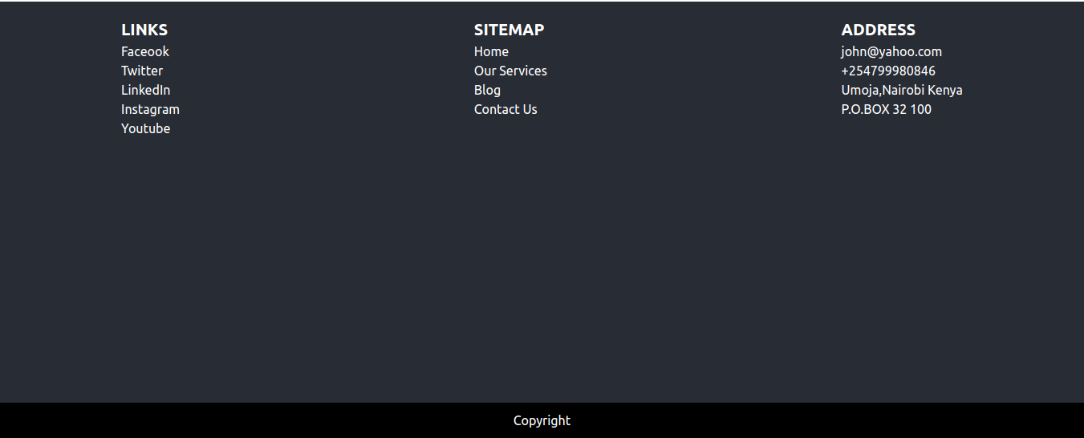*Figure 5: Footer Section*

# Digital Tool and Techniques

Digital marketing can also be referred to as online marketing. It is a way to market and eventually sale products online using digital techniques and tools (Sathya, 2015). Digital marketing provides for an effective way of keeping company information up to date with its customers and clients (Paks.pk, 2021). Some of the digital marketing tools and techniques are mentioned and described in details as follows:

## Facebook Ads for digital marketing

When it comes to digital marketing, Facebook is a master piece. There have been a lot of courses released around developing digital marketing brands using Facebook Ads. Creating successful ads and bands involves little knowledge to master how to use Facebook Ads to create meaningful content that can be able to generate some income.

The following are the various steps that are required in order for use to build a successful digital marketing presence using Facebook:

### Improving our business page.

Our company has an official business page that needs us to make the most out of it. To do this more efficiently, we have to include or embed some the links about the projects that we have done that are complete and functional. We can also put image screenshots of the amazing UI that he compny designs in order to create more customer interest. This will profoundly give a better sense of business personality and character.

### Facebook Ads

In addition to the profile page, Facebook also offers its own form of Advertising through the use of Facebook Ads. They usually appear on the side of a Facebook application. The Ads usually contains a headline, an image copy a link to the main Facebook profile page or in this case the website application of the company.

We can leverage the Ad section to showcase sample of our projects through links both website and mobile applications that have been hosted in the web or deployed on play store or app store respectively. These links will allow a person visiting any Facebook page to visit any of the applications that we have designed and probably visit them or download the app depending on whether that will be the thing that they will be looking for.

## Google Ads for Digital Marketing

We will use Google Ads to create to advertise the various solutions and programs that ELS software compare offers in terms of software development in Mobile and Website applications. The add platform will give as an immense opportunity to advertise in the world’s two largest search engines; YouTube and Google.

The company needs to profoundly make use of the Google Ads. There are many Ads on Google Search in this modern time more than any other time. The most common type of Google Ad that the company make great use of is Display Ads and App Ads. Display Ads will be used for displaying the company information through images and Banners. The images and banners will contain an image of a project that the company has designed and build embedded with a link to the specific project which can be a website application or a mobile application.

# Digital Metrics

## Facebook Insights

This metric tool will be use to analyze traffic on our Facebook Business page important on tracking user interaction on the page. This tool is so much powerful that it will help us to determine the time of the day to post, which day of the week to post and the content that is likely to be viewed by most of the users.

The information on our Facebook business page will be constantly updated to the Facebook Insight's admin page. Another important feature of the Facebook Insights is the virality of a post. This means that for every post we make on the page, which can be a business post announcing a partnership or an iconic event in a company, we can be able to determine which is the most likely post that will go viral and be able to customize other poss to make it possible for a larger audience outreach.

## Google Analytics

Google Analytics is such an important tool that will we be using to measure an analyze the performance of our website application. This tool can be used to measure the results of individual campaigns in real-time and compare the data at different periods. The tool measures different traffics through the following channels; organic search, paid search, social media referrals and backlinks.

Organic search engine optimization (SEO) refers to techniques used to obtain a higher ranking of a website on a search results page and it includes a collection of methods such as use of keywords, backlinking and high-quality content. A higher SEO score on google analytics shows that our website application has been properly designed.

Social media informatics signify how well our website application and hence the company is visible on the different social media platforms such as Facebook, Instagram and Twitter.

# Conclusion

From the customer journey map design that we have discussed in our project, we have analyzed the significance of the journey map in details. Journey maps help to significantly improve the user experience in our website application. We have also discussed the importance of a businesses in leveraging the digital marketing tools, both free and propriety in promoting their services and products online in order to reach a massive client base.

# References

1. Martinez, A. (2018). Customer journey mapping for web designers and developers. [online] GoDaddy Blog. Available at: https://www.godaddy.com/garage/customer-journey-mapping-for-web-designers-and-developers [Accessed 28 Apr. 2022].
2. Alvarez, J., Léger, P.-M., Fredette, M., Chen, S.-L., Maunier, B. and Senecal, S. (2020). An Enriched Customer Journey Map: How to Construct and Visualize a Global Portrait of Both Lived and Perceived Users’ Experiences? Designs, [online] 4(3), p.29. Available at: <https://www.mdpi.com/2411-9660/4/3/29/pdf>.
3. Sathya, P. (2015). A Study on Digital Marketing and Its Impact. [online] International Journal of Science and Research (IJSR) ISSN. Available at: <https://www.ijsr.net/archive/v6i2/ART2017664.pdf>.
4. Paks.pk. (2021). [online] Available at: [here](http://khanalmas.paks.pk/international%20journal%20of%20u%20and%20e%20services.pdf?i=1).